**Johnathon Jack Moore Task 3 Write-Up 2/21/2019**

**2/18** - Alec handed off the Raspberry Pi to me, however due to the load from other classes I postponed working on the assignment till Wednesday night.

**2/20** - I plugged up the pi and began work.

The assignment was Parallel Programing meaning that I was to write a code that utilizes the multiple cores of the CPU after finishing the initial “Foundation” section and answering the questions given I began working with the pi directly.

My first issue was that I had no prior experience with the Pi so I had to play around with it for 30 minutes.

The instructions were fairly simple for the assignment however. After reading the basic tutorial for programming, I analyzed the code provided in an attempt to understand OpenMP and how its allows programs to run blocks of code concurrently rather easily.

This is my process through the programming section step by step:

2.2 Copying the code was giving me issues so I typed it in manually and found a missing “>” in the given code. I created spmd2 and made the executable. Below is the completed code:

I then ran the executable to get an output. I ran it a couple of times with different values.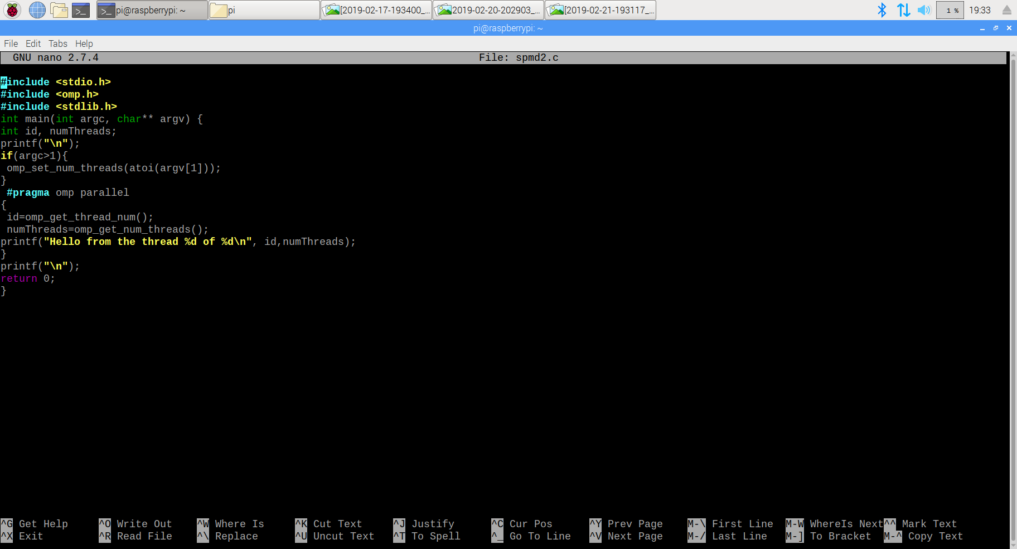

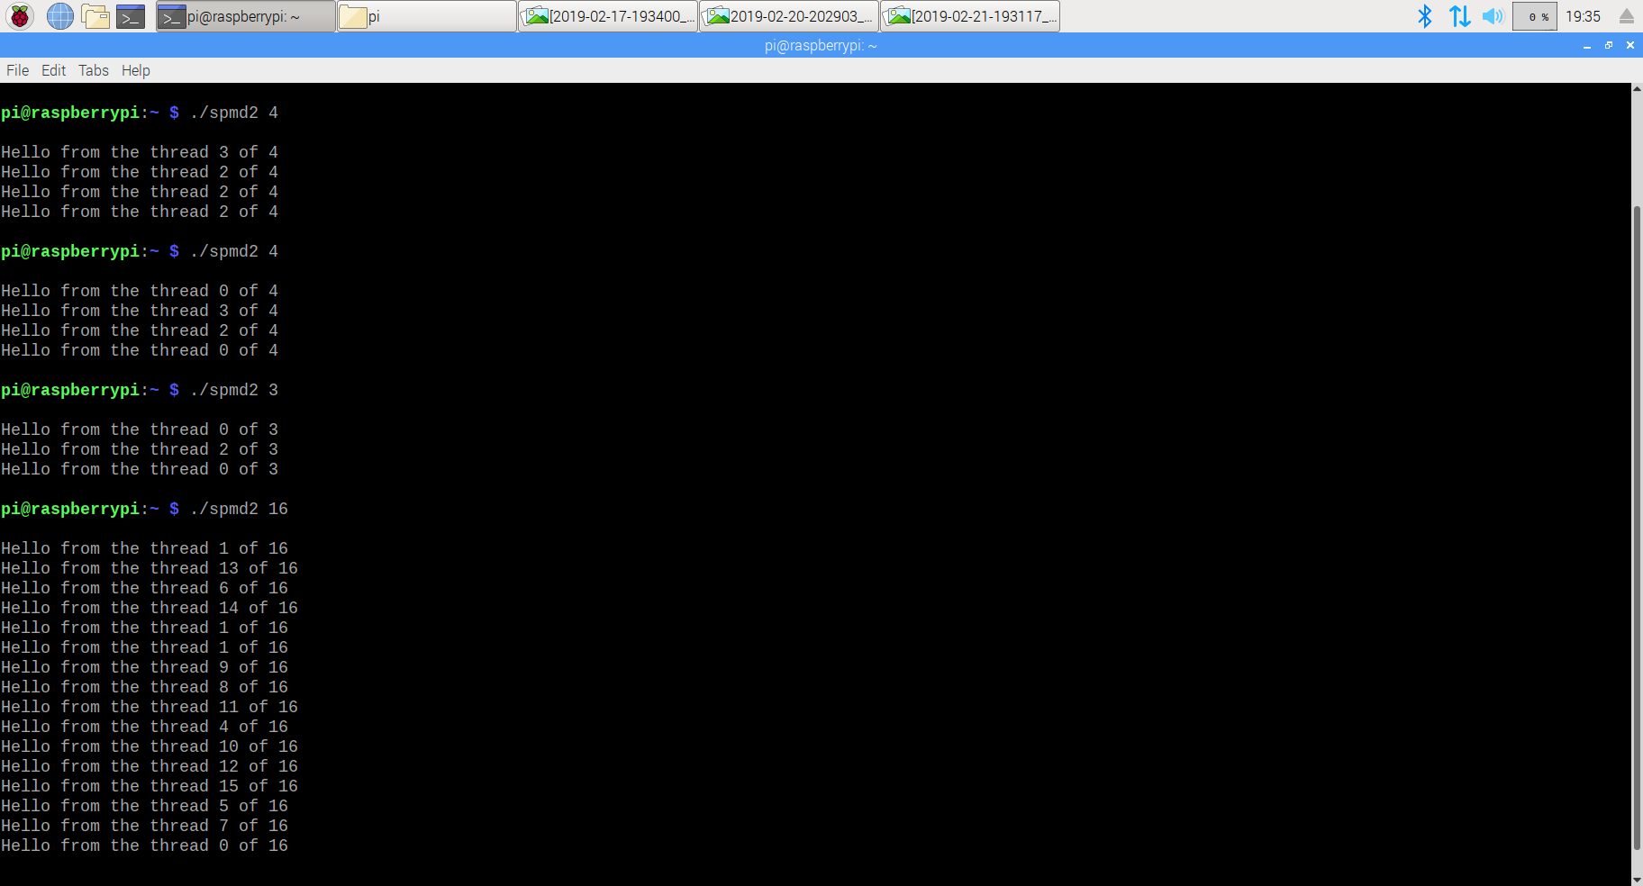

The number after the command to run spmd2 represents how many instances of the print block will be run (how many threads to fork) and the desired goal is to have no repeating threads. As you can see however there was issues to look into causing repeats.

2.3 The order being out of place is not an issue in terms of this assignment. What is an issue however, is that there are repeating numbers within the threads. This seems to be an issue with the variables being initialized outside of the block that will be forked. The issue was surprisingly easy to understand after reading the corresponding text within the assignment.

2.4 After commenting out the declaration line using ”//” and editing the initialization lines to have the declaration within them, the code looked like this:

As you can see only lines 5, 12 and 13 were changed while moving the declarations.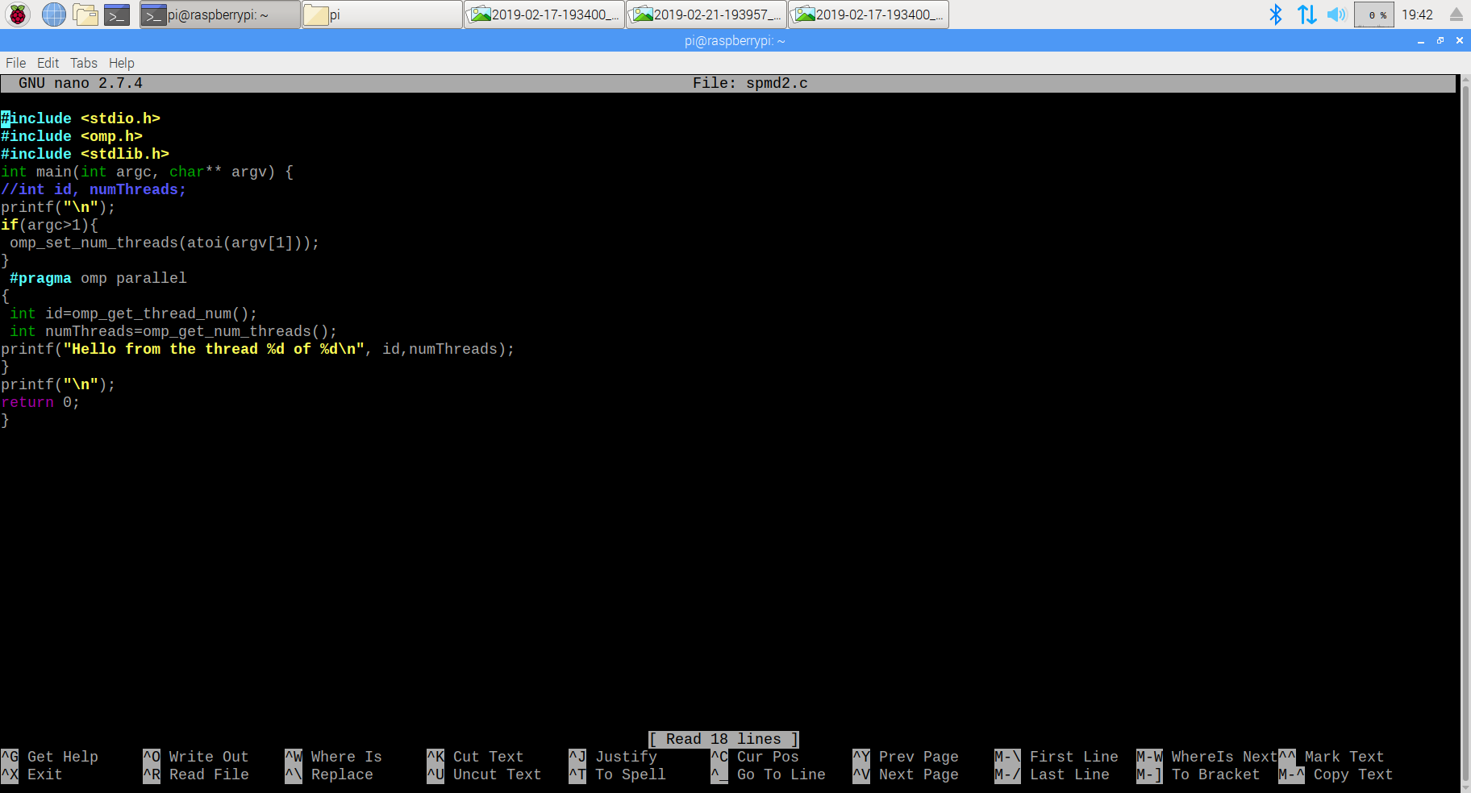

The result of these changes are shown here: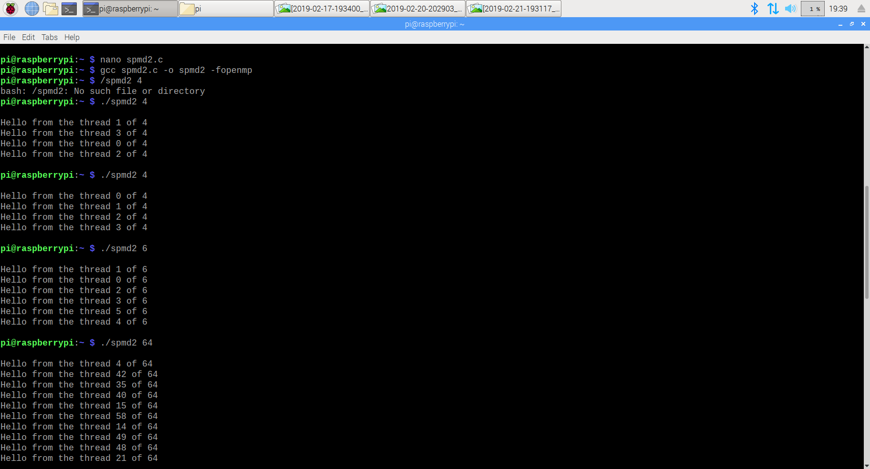

The code worked and showed no repeats no matter what size I chose! Meaning that the fix was successful.

With the code corrected and the desired output, the Task is finished!

2/21 I went back into the Pi to retake screenshots for a higher font size.